A

PROJECT REPORT

ON

KNOWLEDGE SHARING

Submitted to

Chhattisgarh Swami Vivekanand Technical University , Bhilai(India)
in partial fulfillment of requirement for the Award of Degree
of
Bachelor of Engineering

In

Information Technology

By
Kumari Priya
(Enrollment No : AA9850)
&
Megha Bokadey
(Enrollment No : AA9854)

Under the Guidance of
Lect. (Mr.) Rajkumar Singh


Department of INFORMATION TECHNOLOGY
Bhilai Institute Of Technology

Bhilai House, Durg -491001, CHHATTISGARH , INDIA
(An ISO 9002 Certified Institute)

Session : 2009-2010

DECLARATION

I the undersigned solemnly declare that the report of the project work entitled
Knowledge Sharing is based on my own work carried out during the course of my study under the supervision of Mr. Rajkumar Singh.

I assert that the statements made and conclusions drawn are an outcome of my research work. I further declare that to the best of my knowledge and belief the report does not contain any part of any work which has been submitted for the award of any other degree/diploma/certificate in this University or any other University of India.

(Signature of the Candidate)

Name of the Candidate : Kumari Priya
Roll No. : 3013306019
Enrollment No. : AA9850

(Signature of the Candidate)

Name of the Candidate : Kumari Priya
Roll No. : 3013306019
Enrollment No. : AA9850
Signature Of Supervisor

Mr.Rajkumar Singh
(Lecturer)
Information Technology
B.I.T. , Durg(C.G.)

CERTIFICATE BY THE SUPERVISOR

This is to certify that the report of the project submitted is an outcome of the project work
entitled Knowledge Sharing carried out by
Kumari Priya (Roll No. : 3013306019 & Enrollment No. : AA9850)
&
Megha Bokadey (Roll No. : 3013306021 & Enrollment No. : AA9854)
under my guidance and supervision for the award of Degree of Bachelor Of Engineering in Information Technology branch of Chhattisgarh Swami Vivekanand Technical University , Bhilai (C.G) , India.
To the best of my knowledge and belief the project
- Embodies the work of the candidate herself ,
- Has duly been completed,
- Fulfills the requirement of the Ordinance relating to the B.E. degree of the University
- Is up to the desired standard both in respect of contents and language for being referred to the examiners .

( Signature of HOD with seal ) (Signature of the Supervisor)

Name : (Mr.) Rajkumar Singh
Designation : Lecturer
Department : Information Technology
Name & Address : B.I.T. Durg(C.G.)
of the Institute

Forwarded to Chhattisgarh Swami Vivekanand Technical University
Bhilai

( Signature of Director/Principal )
Bhilai Institute Of Technology
Bhilai House Durg-491001 ,

CHHATTISGARH , INDIA

CERTIFICATE BY THE EXAMINERS

This is to certify that the project entitled Knowledge Sharing submitted by
Kumari Priya (Roll No. 3013306019 Enrollment No. AA9850)
&
Megha Bokadey (Roll No. 3013306021 Enrollment No. AA9854)
have been examined by the undersigned as a part of the examination and is here by recommended for the award of the degree of Bachelor of Engineering in Information Technology branch of Chhattisgarh Swami Vivekanand University , Bhilai (C.G) .

Internal Examination External Examination
Date : Date :

ACKNOWLEDGEMENT

We wish to acknowledge with a deep sense of hearty gratitude and indebtedness to Prof.(Dr.) M.K Kowar Principal , BIT Durg , Mrs Arpana Rawal , Head of Department I.T. , who gave us this opportunity to experience project work & their valuable suggestion during this project have been invaluable.

We take this opportunity to voice & record our sincerest gratefulness towards our esteem Supervisor Lect. (Mr.) Rajkumar Singh under whose able guidance the project work has been brought to completion.

Our heart leaps up in thankfulness for his benevolence & time to time help, valuable suggestions, constructive criticism & active interest in the successful completion of this project work.

We are also thankful to all our honorable teachers of the Information Technology Department and our parents whose valuable support helped us and kept us motivated all through.

(Signature of Student ) (Signature of Student)

Name : Kumari Priya Name : Megha Bokadey BIT,Durg(C.G.) BIT, Durg, (C.G)

INDEX

INTRODUCTION

Knowledge Sharing is a web application to help students of any academic institution to facilitate necessary teaching faculty at any time they require in resolving their doubts , queries related to subject taught. This forum shall assist the person to share the knowledge in the areas of their expertise.

Knowledge Sharing is a local area network where our users (school students , college students , Teachers / Faculties , Working Professional , etc.)integrate & invite friends to grow their network.

Knowledge Sharing is an enabler where it enables users to create network & find necessary people at any time they require. It connects people who might wish to mutually assist among themselves , in the areas of their expertise.

This web application can also be used for group messaging. It provides the facility of community (groups) in which there are people in various groups (like group of students belonging to same branch or same semester) so that common notice can be send to all the members of that particular group.

Objective :

To share knowledge with the students about their doubts & queries by the faculties in their areas of expertise.

Purpose :

- To find people who can help in solving queries.
- Mutually assits people in areas you are good at.
- To find people whose intellectual knowledge matches yours.
- Keep in touch with your friends intellectual & career details.

Scope :

This can be used for sharing knowledge & doubts or queries or any information to particular group for users like students , teachers by connecting them in a LAN (Local Area Network).

REVIEW OF LITERATURE

Problem Definition :

Knowledge Sharing is a web application to help students of any academic institution to facilitate necessary teaching faculty at any time they require in resolving their doubts , queries related to subject taught. This forum shall assist the person to share the knowledge in the areas of their expertise.

It also provides the facility of community (groups) in which there are people in various groups (like group of students belonging to same branch or same semester) so that common notice can be send to all the members of that particular group.
Or individual notices can also be send to a particular user through this network.

REQUIREMENTS & ANALYSIS

REQUIREMENTS SPECIFICATION

REQUIREMENT SPECIFICATION :

It is the set of complete & precisely stated properties along with the constraints of the system that our application must satisfy.
Based on problem defined earlier certain requirements are their in order to overcome those problems , such as :

- User Requirement :

- User need to register themselves in this network.
- Enter correct username & password for login.
- Changing of password & their personal setting.
- Send individual or community scraps.
- Create community.
- Join community.
- Remove user’s own account from the network.

- System Requirement Specification :

Hardware Requirements :
- Pentium III processor (or higher)
- 256 MB RAM

Software Requirements :
- Front End : HTML
- Scripting Language : J2EE
- Back End : MS Access
- Operating System : Windows XP
- Editor : Net Beans 5.0
- Web Browser : Internet Explorer

PLANNING

Planning includes :

- The most important step is to decide the approach or model we are choosing to develop this project.
For this project we are choosing the prototype model where the requirement has been gathered earlier only, based on which designing is to be done. Often the end users may not be able to provide a complete set of application objectives, detailed inputs etc. thus cycle starts by listening to the user, followed by building or review and testing for the user satisfaction and then Maintenance and adding more facilities in them.

The other purpose behind using this model is to illustrate the input data formats, messages, acknowledgements etc. This is a valuable mechanism for gaining better understanding of user’s needs :
- How the screens might looks like.
- How the user interfaces would be have.
- How the system would produce output.

- Based on the purpose of using prototyping, we include:
- Queries by the applicants or existing users must be gathered and separate interface has to be provided and to be settled at the earliest.
- Providing the login form for the existing users and providing the id and password validations on it so the unauthorized access can be eliminated.
- Providing simple registration process for the new applicants and cannot be conflicted with the existing user id.
- Providing the instructions to the users that are to be followed while registering themselves.
- Providing the user their private work area where they can work in full security.
- Keep track of the users that has logged into the system and when he has logged out.

DATA FLOW DIAGRAM

Context Level (0th - Level)

KNOWLEDGE SHARING
USER
DATABASE

First Level (1st - Level)

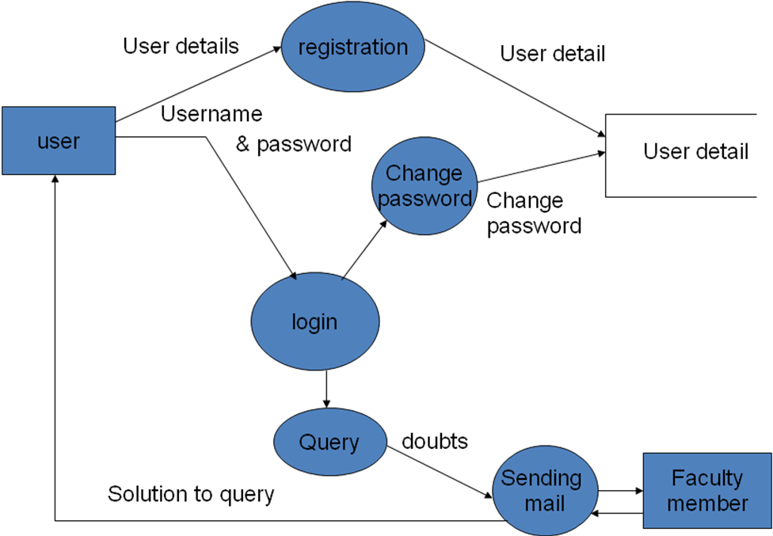

SYSTEM DESIGN

Basic Modules

- Basic Modules :
While designing the system it is necessary to divide the whole system into modules, such that it is easy to accomplish each task easily and efficiently.
Modules helps us to develop the system in parts while later can be joined to form a single module or system. It is also considered as the down-top approach in which small tasks are performed first, and then each module can be joined together such that they are termed as a single task.

Basic modules in which this system has been divided are:
1. Form validation.
    - Database connectivity.
    - Session tracking via cookie generation.
    - Authorized access to the system database.
    - Entertaining the queries.
    - Proper response to the queries.
    - Calendar to the system used to set the date of reminders.
    - Acknowledgement for queries and registration.
    - Service that regularly matches the reminder database for the current time periods reminders, that is to be sent automatically to the members email addresses.

These basic modules can be bifurcated into different categories:
Input Module
In the input module input pages like new registration, new coordinator, new reminders etc are taken.
      - Adding details to the Users.
      - Adding reminders.

Output Module
In this output module the details of the object which have entered in the database like Member Details, reminders etc.
          - Display reminders all the reminders.
          - Display Member Details.
Password Module
In this module authentication of the Admin and members, the member who is login/logout is the authorized part of the system. Also the module will check same things in the case of Admin /coordinator.
- Password authentication for Admin.
- Password Authentication for Members.
Deletion Module
In this deletion module deletion of user and reminder are done.

